Justine Denise B. Hernandez February 17, 2025

1. What have I done so far?

Fixed the functionality for the Create Announcement Screen

* Can select multiple tags

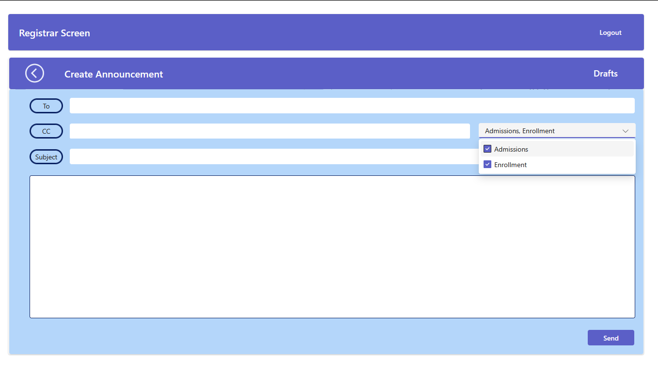

* Save as draft

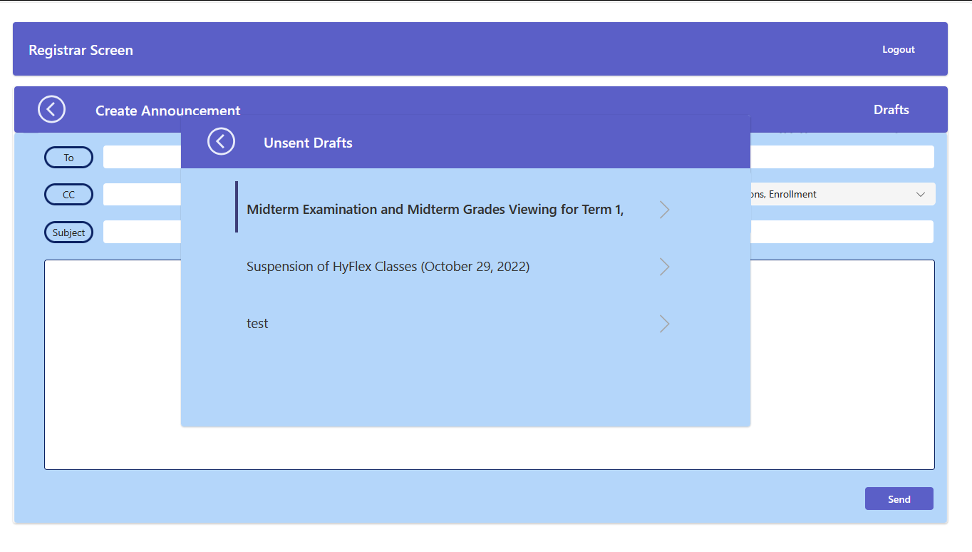

* Schedule Send

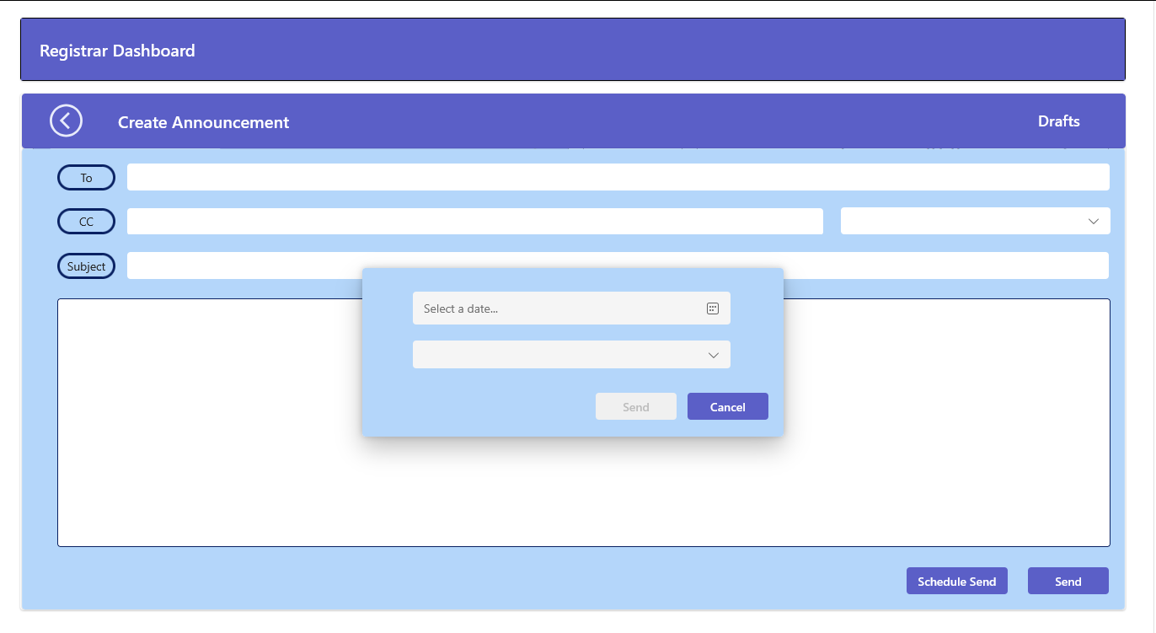

1. What will I do next?

* Fix the UI for the screens

1. Possible challenges?

* Handling of time in the schedule send function